This is the Title of the Abstract This is the Title of the Abstract
John A. Authora¹, John A. Authorb² and John A. Authorc³
¹ Affiliation of Author-a
² Affiliation of Authora-b
³ Affiliation of Author-c
authora@univa.edu, authorb@univab.edu, authorc@univc.edu

Plasmas are wonderful things that make people happy and life more enjoyable [1]. Attend Hakone to learn more about making people happy with plasmas. Plasmas are wonderful things that make people happy and life more enjoyable. Attend Hakone to learn more about making people happy with plasmas. Plasmas are wonderful things that make people happy and life more enjoyable. Attend Hakone to learn more about making people happy with plasmas. Plasmas are wonderful things that make people happy and life more enjoyable. Attend Hakone to learn more about making people happy with plasmas.
Plasmas are wonderful things that make people happy and life more enjoyable. Attend Hakone to learn more about making people happy with plasmas [2]. Plasmas are wonderful things that make people happy and life more enjoyable. Attend Hakone to learn more about making people happy with plasmas. Plasmas are wonderful things that make people happy and life more enjoyable. Attend Hakone to learn more about making people happy with plasmas. Plasmas are wonderful things that make people happy and life more enjoyable. Attend Hakone to learn more about making people happy with plasmas.
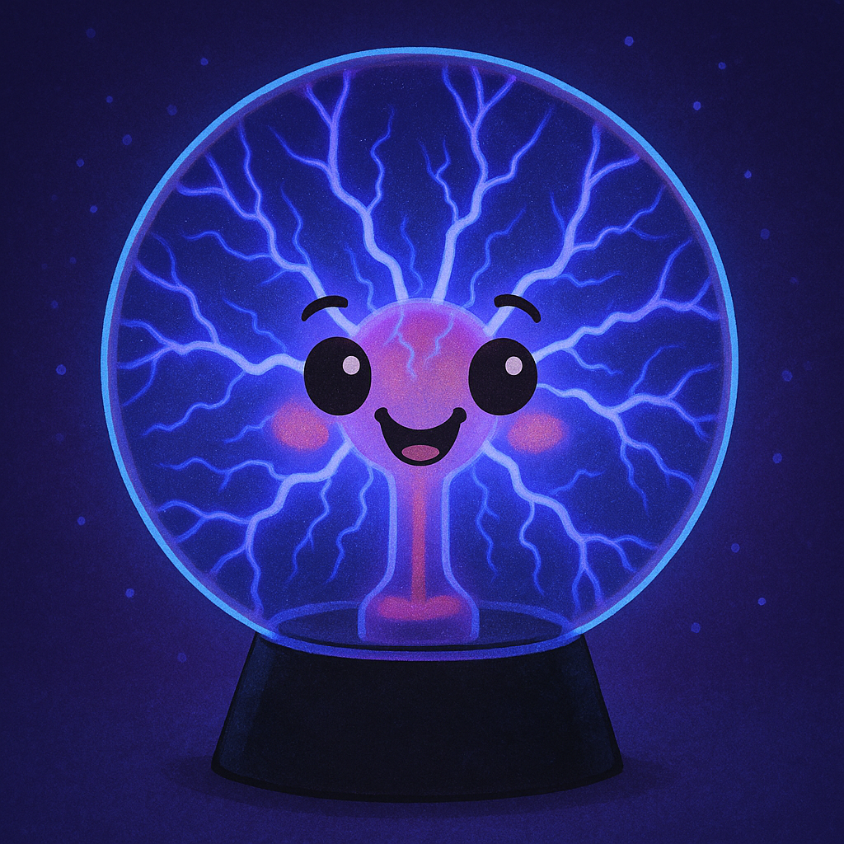
Image was produced using GPT-Image-1 with the prompt "create a happy plasma using a plasma globe as a model".
Plasmas are wonderful things that make people happy and life more enjoyable [3]. Attend Hakone to learn more about making people happy with plasmas. Plasmas are wonderful things that make people happy and life more enjoyable. Attend Hakone to learn more about making people happy with plasmas. Plasmas are wonderful things that make people happy and life more enjoyable. Attend Hakone to learn more about making people happy with plasmas. Plasmas are wonderful things that make people happy and life more enjoyable. Attend Hakone to learn more about making people happy with plasmas.
Plasmas are wonderful things that make people happy and life more enjoyable. Attend Hakone to learn more about making people happy with plasmas. Plasmas are wonderful things that make people happy and life more enjoyable. Attend Hakone to learn more about making people happy with plasmas. Plasmas are wonderful things that make people happy and life more enjoyable. Attend Hakone to learn more about making people happy with plasmas. Plasmas are wonderful things that make people happy and life more enjoyable. Attend Hakone to learn more about making people happy with plasmas.
References:
[1] J. Smith et al., J. Best Phys. 13, 1300 (2023)
[2] M. Jones et al., J. Newest Phys. 14, 1400 (2024)
[3] K. Morning., J. Wrong Phys. 15, 1500 (2025)

